WEEKLY LESSON NOTES
WEEK 6
Week Ending: |  | DAY: |  | Subject: Science
Duration: |  |  |  | Strand: Systems
Class: B7 |  | Class Size: |  | Sub Strand: Farming Systems
Content Standard:  B7.3.4.1 Demonstrate an understanding of the differences among the various farming systems: Land Rotation, Crop Rotation, Mixed Cropping, Mixed Farming, and Organic Farming |  |  | Indicator:  B7.3.4.1.1 Examine and discuss the differences among the various farming systems |  | Lesson:  1 of 2
Performance Indicator:  Learners can discuss the differences among the various farming systems |  |  |  | Core Competencies:  CC 9.6: CC 8.1: CC 8.4: DL 5.5: DL 5.6: CP 5.1:
References: Science Curriculum Pg. 23-24
Phase/Duration | Learners Activities |  |  |  |  | Resources
PHASE 1: STARTER | Using questions and answers, review to find out what learners already know about farming system.  Share learning indicators and introduce the lesson.
PHASE 2: NEW LEARNING | Brainstorm learners for the meaning of farming systems.  Farming system refers to all the different methods which are used to produce crops and or animal.  Learners to mention some farming methods being practiced in their community.  Example:  Shifting cultivation  Land Rotation  Crop Rotation  Mixed Cropping  Mixed Farming  Organic Farming.  Guide learners to discuss the factors that determine a particular farming method.  Example:  - Land availability and soil type  - Climate pattern  - The type of tools available (e.g. cutlass, hoe, tractors, etc)  - Source of water for irrigation  - Availability of labor  - Availability of extension officers to provide technical support.  Guide learners to discuss the shifting cultivation method of farming and its characteristics.  Shifting cultivation.  This is a system of farming in which the farmer cultivates a piece of land for some time, the land when it loses its fertility together with his settlement. The farmer may come back to cultivate the old land later.  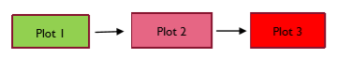  Learners assess the advantages and disadvantages of shifting cultivation.  Advantages of Shifting cultivation  1. Land previously used is allowed to fallow so as regain its fertility.  2. Farmer spends little or nothing in improving the soil fertility.  3. The farmer could grow crops on any new land he moves to.  Disadvantages of Shifting cultivation  1. Due to increasing population and resultant pressure on land, this system is difficult to practice.  2. The would always have to move or relocate his household.  3. This type of farming system is expensive because of the constant clearing of new land.  Again, learners discuss the land rotation method of farming and its characteristics.  Land rotation.  This is a system of farming in which a farmer cultivates a piece of land for some time and leaves it to clear a new land when the old land becomes less fertile. The farmer moves to the new land without moving his settlement.  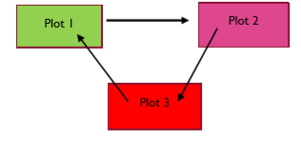  Assessment  - What is a farming system?  - State four factors that determines a particular farming method.  - Describe briefly any two farming methods and state two advantages and two disadvantages of it. |  |  |  |  | Pictures and Charts
PHASE 3: REFLECTION | Use peer discussion and effective questioning to find out from learners what they have learnt during the lesson.  Take feedback from learners and summarize the lesson.

Week Ending: |  | DAY: |  | Subject: Science
Duration: |  |  |  | Strand: Systems
Class: B7 |  | Class Size: |  | Sub Strand: Farming Systems
Content Standard:  B7.3.4.1 Demonstrate an understanding of the differences among the various farming systems: Land Rotation, Crop Rotation, Mixed Cropping, Mixed Farming, and Organic Farming |  |  | Indicator:  B7.3.4.1.2 Categorize different farming systems |  | Lesson:  2 of 2
Performance Indicator:  Learners can categorize different farming systems |  |  |  | Core Competencies:  CC 9.6: CC 8.1: CC 8.4: DL 5.5: DL 5.6: CP 5.1:
References: Science Curriculum Pg. 23-24
Phase/Duration | Learners Activities |  |  |  |  | Resources
PHASE 1: STARTER | Using questions and answers, review learners understanding in the previous lesson.  Share learning indicators and introduce the lesson.
PHASE 2: NEW LEARNING | Revise with learners on the shifting cultivation and land rotation methods of faming.  Guide learners to identify and define other types of farming systems in Ghana and elsewhere.  Crop rotation is the practice of growing a series of dissimilar or different types of crops in the same area in sequenced seasons.  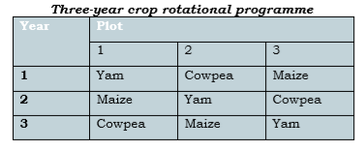  Engage learners to discuss the principles of crop rotation.  Example:  - Deep rooted crops are followed by shallow rooted crops  - Crops that belong to the same family should not follow each other, etc.  Advantages of crop rotation  1. There is reduction of total crop failure  2. Soil fertility is maintained because of the inclusion of leguminous plants  3. Crop rotation controls soil erosion.  Disadvantages of crop rotation  1. Special skill is required in carrying out this type of farming system.  2. Cultural practices are difficult to carry out on the same piece of land because different crops are involved  Engage learners to differentiate between land rotation and crop rotation.  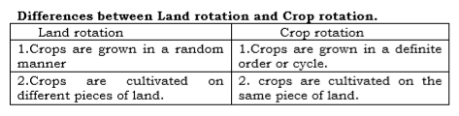  Learners to discuss the characteristics of the mixed farming and mixed cropping methods of farming in Ghana.  Mixed cropping, also known as inter-cropping or co-cultivation, is a type of farming that involves planting two or more of plants(crops) simultaneously in the same field.  Advantages of mixed cropping  1. Different crops may be harvested at different times. This helps the farmer to get food over a long period.  2. Since different crops are grown, pests and diseases may not spread easily.  3. Where cover crops or legumes are grown, they soil fertility.  Disadvantages of mixed cropping.  1. The crops may compete for nutrients, water, light and space for survival.  2. Different fertilizers may be needed in some cases, for different crops. This could increase the cost of production.  3. Mechanization is difficult. 4. Improper spacing may lead to shading of other crops.  Mixed farming  Mixed farming is the cultivation of crops along with rearing of animals for meat or milk on the same farm.  Advantages of mixed farming.  1. The is regular supply of food for the farmer and his family.  2. The fertility of the soil is improved by the use of farm yard manure.  3. There is no need for the farmer to shift to a new piece of land since there is less likelihood of low soil fertility.  Disadvantages of mixed farming.  1. The farmer may have divided attention for keeping both crops and animals.  2. It requires a lot of skills in managing crops and animals.  3. Animals usually destroy crops when they are not well confined.  Have learners compare and contrast the characteristics of mixed farming and mixed cropping methods of farming.  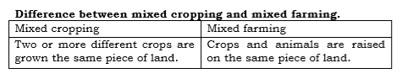  Assessment  - You are given the following crops; cassava, sorghum, garden eggs, and soya beans. Use the principles of crop rotation to draw-up a four year rotation plan. |  |  |  |  | Pictures and Charts
PHASE 3: REFLECTION | Use peer discussion and effective questioning to find out from learners what they have learnt during the lesson.  Take feedback from learners and summarize the lesson.

